The U of T Trauma Program
is a collaborative of the Departments of Surgery of
St. Michael’s hospital, Sunnybrook health sciences centre, and the hospital for sick children.
It is designed to promote quality patient care, education, and research across three sites and to integrate trauma related activites in the areas of education, quality and research.

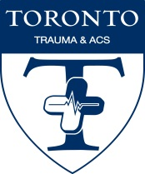
University of Toronto
TRAUMA PROGRAM

Volume 3, Issue 1 :: Spring/Summer 2016

Each edition of the newsletter will highlight the initiatives of one of the three trauma centres in the GTA that make up the U of T Trauma Program. This newsletter will focus on Sunnybrook Health Sciences Centre.

FOCUS: Sunnybrook Health Sciences Centre

Trauma Program Coordinator
Tory Regional Trauma Centre at Sunnybrook Health Sciences Centre is proud to announce the hiring of our new trauma program manager: Ms. Sharon Ramagnano. Sharon returns to Sunnybrook after working at Trillium Gift of Life as Director, Policy, Education and Professional Practice. Sharon has returned to her “professional roots”, as she was previously the Nurse Educator for the Emergency Department at Sunnybrook before leaving for Trillium Gift of Life. Sharon has already established our Trauma Centre website, http://surgery.utoronto.ca/programs/trauma, which will immensely improve internal and external communications. We look forward to Sharon’s energy and dedication to push our Trauma agenda forward.

Clinical Care in Trauma
One of the main foci of our Trauma Strategic Plan has been improving trauma survivorship and quality of life post-injury. Many of our recent partnerships and hires have been aimed at addressing this priority. We are pleased to announce the hiring of Dr. Luis Daluz as one of our new trauma hospitalist. Dr. Daluz completed his surgical training in Brazil. After moving to Canada, he has completed a trauma surgery fellowship, a fellowship in critical care medicine at Sunnybrook, and then his Master’s Degree from the Institute of Medical Sciences. Dr. Daluz will join Dr. Nascimento on our trauma hospitalist program, focusing his attention on trauma resuscitation in the trauma room, and on improving transitions of care on the C5 trauma ward, particularly for more chronic patients. We have also partnered with both the Departments of Psychiatry and Physical Medicine at Sunnybrook to improve quality of life post injury. With Dr. Ed Hanada and Dr. Larry Robinson, Tory Trauma Centre will be incorporating physiatry as a key consultative service for trauma patients to improve their functionality and quality of life, as well as to reduce their hospital length of stay. We have also partnered with the Department of Psychiatry to create an in-hospital screening program for Post-Traumatic Stress Disorder (PTSD), as well as an outpatient clinic for trauma patients suffering from PTSD.

Trauma Education
Tory Trauma Centre continues to develop and contribute to regional, provincial and national knowledge translation programs to enhance rural trauma care. Sunnybrook has partnered with the Department of Family and Community Medicine at Mt. Sinai Hospital to provide clinical trauma rotations to family doctors enrolled in the SEME (Supplementary Emergency Medicine Experience) program. In this program, rural emergency medicine physicians throughout the province are funded by the Ministry of Health to return to university teaching hospitals to enhance and upgrade their emergency medicine skills. Our hope is that the trauma rotation at Sunnybrook will improve the trauma care in rural Ontario, and help these physicians recognize those patients who would benefit from early transfer to a trauma centre. Sunnybrook has already partnered with the Canadian Armed Forces to provide similar experiences for Canadian military physicians, in preparation for overseas deployments. Finally, Sunnybrook has partnered with Ornge, Ontario’s Air Ambulance service, to provide CME (Continuing Medical Education) Trauma Sessions to nurses who work at remote nursing stations in the Northwest, providing care to First Nations communities.

University of Toronto Trauma App
The content is distributed freely on the web (m.trauma.utoronto.ca) and through the major app stores with updates released semiannually. When learners start a new rotation, exposure to the app is included in their orientation package and posters in EDs, trauma bays, and trauma wards remind team members to download the software.

What has perhaps proven most surprising is the wide attention the app has received outside of the GTA. As of December 31st 2015, the app has been downloaded over 17,000 times and from 149 different countries. The overall rating is 4.5/5 stars and users continue to leave positive reviews. The U of T Trauma Program fields many questions from others looking to set up similar apps either in trauma care or related to their field.

What should we expect next from the app? The founding team continues to update the content as local experts create new protocols and revise old ones. Recently, they have started to incorporate bespoke medical illustrations. It is anticipated that the app will surpass its 20,000th download in 2016.

This continues to be a great example of the University of Toronto being recognized for its trauma leadership not just in Canada but around the world.

The University of Toronto's Trauma App is three years old this spring and continues to garner international attention for the Trauma Program. The app is the result of an impressive collaborative effort among staff from various departments, disciplines, and sites that care for trauma patients.

The app was created to address a very real challenge: while interpreting clinical evidence and creating institutional best practices is important, actually driving adoption at the bedside can be extremely difficult. This is all the more problematic in the University of Toronto's teaching hospitals where much of the trauma workforce is composed of rotating students, residents, and fellows. Although both St. Michael's and Sunnybrook were already moving towards adopting joint protocols, disseminating the information in the form of paper documents was proving challenging. The team wanted a resource that allowed access to Toronto-specific information in the trauma bay, while waiting for a patient to go through the CT scanner, or while rounding in the ICU.

The software that was eventually created by surgical residents Marisa Louridas, Balisi Bakanisi, and Matt Strickland works across the three major mobile platforms (Android, iOS, and web). The app includes distilled versions of protocols approved by St. Michael's, Sunnybrook, the Ross Tilley Burn Centre, and jointly across all sites.

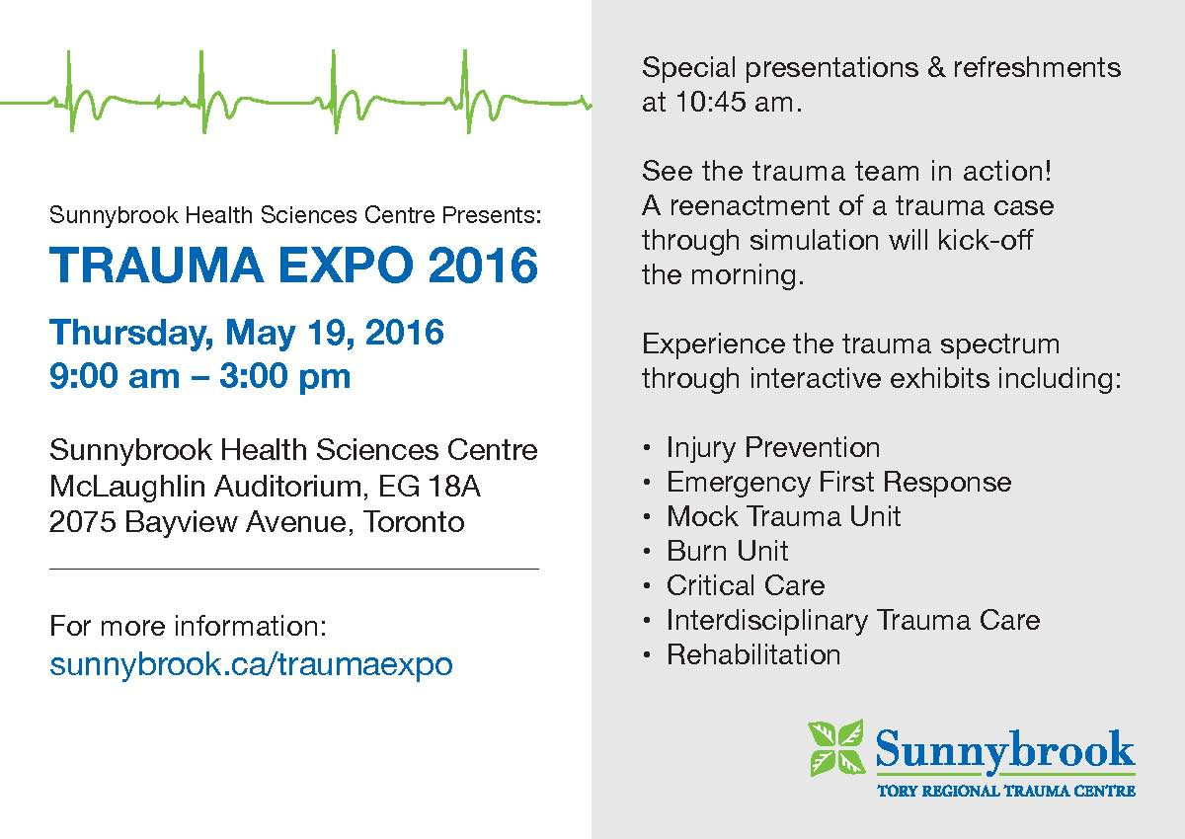

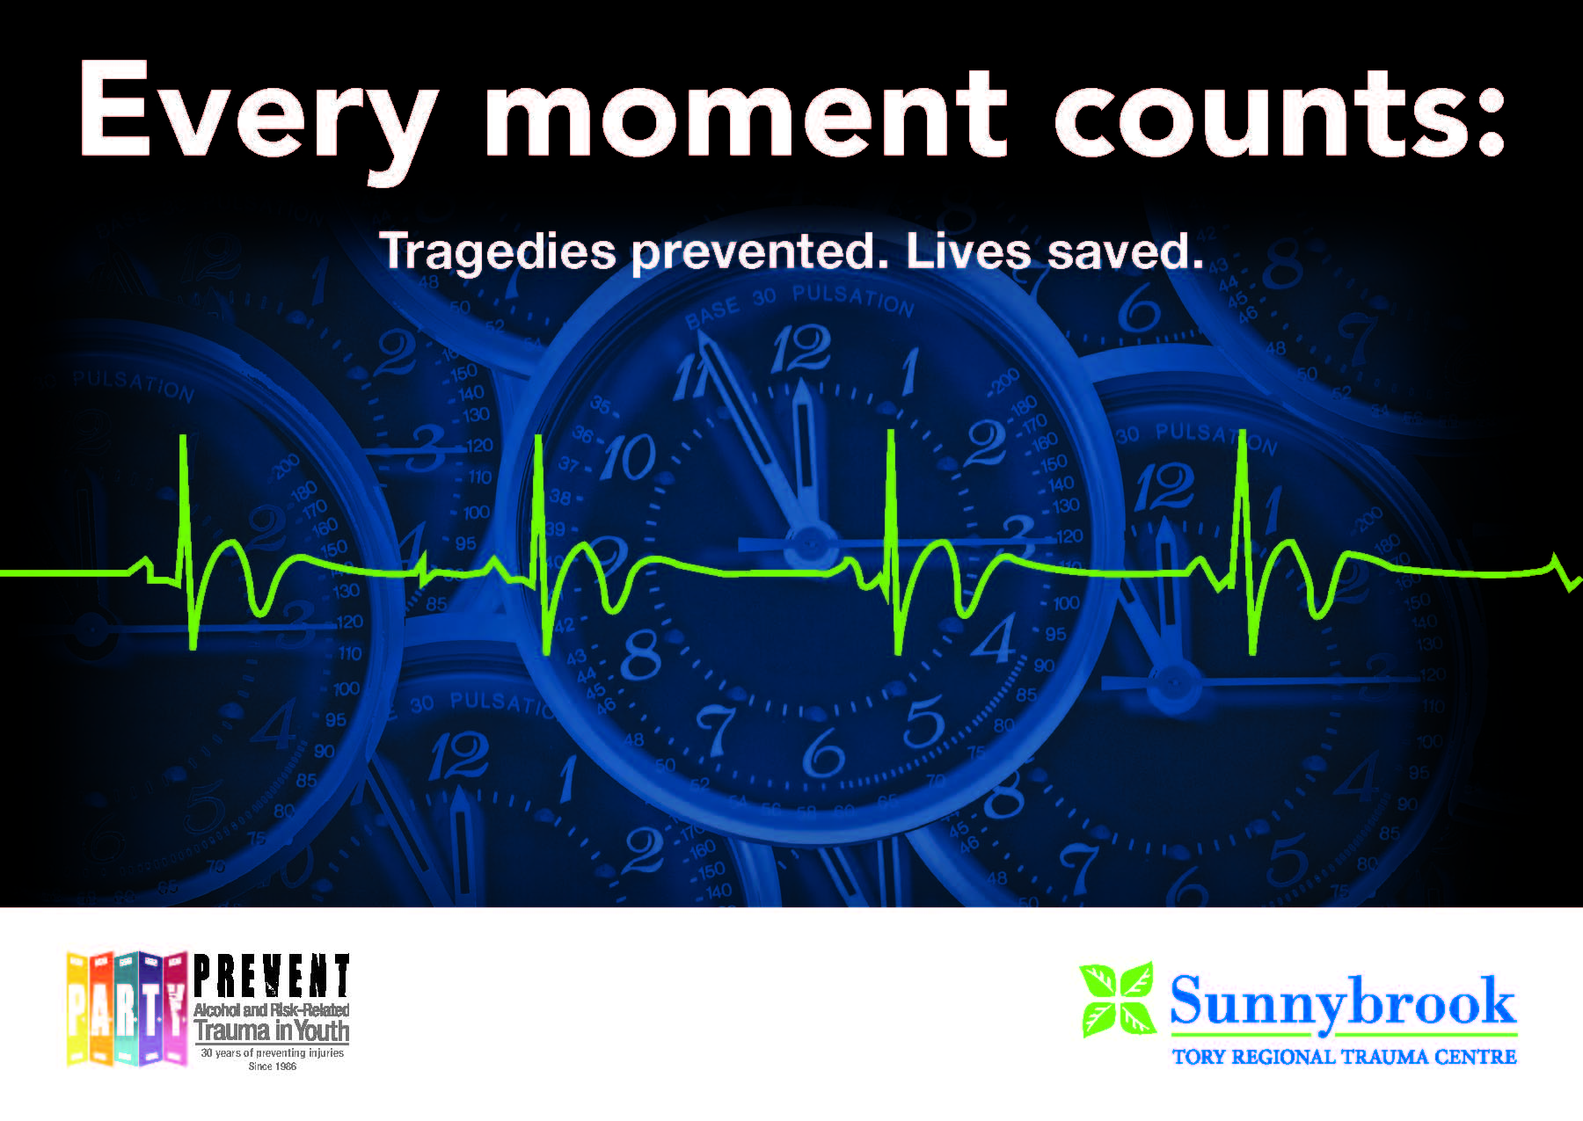

2016 Visiting Professor in Injury Prevention

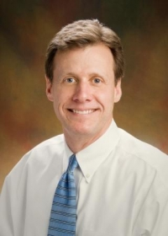
The University of Toronto Trauma Program, in conjunction with the Dr. Tom Pashby Sports Safety Foundation, are hosting the Visiting Professor in Injury Prevention Symposium on April 19, 2016.

Dr. Dennis Durbin is this year's Visiting Professor in Injury Prevention. He is a clinical epidemiologist and an attending physician in the Division of Emergency Medicine at The Children’s Hospital of Philadelphia, and is currently the Director of the Office of Clinical and Translational Research. Dr. Durbin is an internationally recognized leader and recipient of many awards in pediatric trauma research; he has also been a major contributor to national and international policy planning and guidance efforts in reducing motor vehicle-related injuries and deaths among children.

Additional featured speakers include Dr. Michael Cusimano from St. Michael's Hospital and 4 prominent leaders in injury prevention research. For more information, please contact Tammy Kowalyk at tammy.kowalyk@sunnybrook.ca

2016 UofT Visiting Professor in Trauma and Tile Lecturer

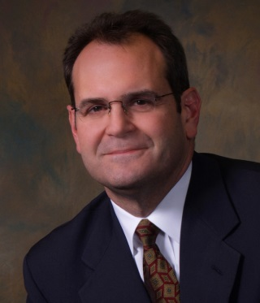
Our 2016 Visiting Professor in Trauma, who also delivers the University of Toronto - Department of Surgery Grand Rounds on June 3rd will be Dr. Geoffrey T. Manley. Dr. Manley is the Chief of Neurosurgery at San Francisco General Hospital and Professor and Vice Chairman of Neurosurgery at the University of California San Francisco (UCSF). He co-directs the UCSF Brain and Spinal Injury Center. Dr. Manley is an internationally recognized expert in neurotrauma. He has published over 200 manuscripts that reflect a wide range of research interests from molecular aspects of brain injury to the clinical care of traumatic brain injury (TBI) patients. He has helped to define new molecular mechanisms and develop advanced neuromonitoring and informatics tools for TBI.

June 2, 2016

6:30 pm - City-Wide Journal Club

By Invitation only

June 3, 2016

7:30 am - Department of Surgery University
Rounds – Tile Lecture

“Traumatic Brain Injury: A precision
medicine approach”

Sunnybrook Health Sciences Centre
– McLaughlin Auditorium EG61

9:00 am - Research Symposium

Sunnybrook Health Sciences Centre
– M6502 Lecture Theatre

Please RSVP to
tammy.kowalyk@sunnybrook.ca

Currently, he leads national and international efforts, funded by public-private collaborations, to create a modern precision medicine information commons. This information commons integrates clinical, imaging, proteomic, genomic, and outcome biomarkers of TBI to drive the development of a new TBI disease classification system. As demonstrated in other diseases, a more precise classification of TBI could revolutionize diagnosis, direct patient-specific treatment, and improve outcomes. His many honors include the Trauma Research Award from the American College of Surgeons and the General Motors Trauma Research Award. He has served as a Consultant for the Prehospital Guidelines Committee for the World Health Organization, and on numerous clinical research committees for the National Institutes of Health, the Centers for Disease Control, and the Department of Defense.

2016 Interdisciplinary Trauma Conference

The 2016 Interdisciplinary Trauma Conference presented by University of Toronto, Department of Surgery in partnership with St. Michael’s Hospital, Sick Kids Hospital and Sunnybrook Health Sciences Centre was a sold out event this year!

The audience for this conference included trauma expert nurses, physicians, allied health professionals, and first responders (police, fire, paramedics) involved in trauma programs or emergency care as well as public health and ministry of health policy makers. This was our fourth annual conference. Over 300 health care personnel from across the province and beyond attended.

The U of T Trauma Program
aims to provide leadership in the delivery of specialized care to severely injured patients, injury related research, and education and injury prevention. provide coordinated patient-focused care recommendations in close collaboration with EMS, referring institutions, and facilities providing pre and post-acute care

This year’s conference focused on road traffic trauma. Our keynote speaker, Dr. Hugh Scully, highlighted the critical role of healthcare providers in motorsport safety. The live demonstration featured a Toronto Fire Services car crash extrication exercise demonstrating the techniques required to manage safe patient extrications in light of new car technologies such as airbags and lighter/stronger metals.

The conference is an important component of trauma system outreach that demonstrates the essential links and bonds between all trauma care providers from injury prevention through acute care and on to rehabilitation. New this year was a tweet wall that logged 782 tweets at the end of the conference with a unique reach of 336,556.

