SURGICAL INFECTIONS POS LECTURE 4
JMA Bohnen Dec 2009
Topics: some common and important surgical infections

S. AUREUS INFECTIONS

Source: blood: native or prosthetic valve, metastastatic from anywhere esp line: contiguous: anywhere (eg skin to bone to joint); aspiration; exog from OR, trauma.
Pathol: Toxin: food poisoning, toxic shock; invasion: 1) abscess incl surgical site, traumatic wounds; skin incl furuncle, carbuncle (coalescence of furuncles); brain; lung; LKKS; bone (osteo); muscle (pyomyositis, incl “tropical,” HIV) 2) regional spread eg cellulitis, fasciitis 3) FB/implant –assoc
Treat Drain, debride, remove FB as nec. Antibiotics for bacteremia, infection deep to skin, regional spread, critically ill, immunocomp, to preserve infected FB. Bacteremia is serious! If remove focus eg line, rx 2 wks clox IV. Deep (eg pneumonia): 3 wks clox IV to prevent metastatic inf’n. For persistent or unexplained S. aureus bacteremia, r/o endocarditis with cardiac echo, and give 4-6 weeks IV clox. MRSA needs vanco or linezolid, TMP/SMZ, qunu-dalpho. VRSA exists. Under treatment common Arch Intern Med 2002;162:25. Late (>48h) rx bacteremia → 4x mort CID 2003;36:1418

ABDOMINAL INFECTIONS

Classification: primary peritonitis: unimicrobial, no GI cause, incl spontaneous bacterial peritonitis (ascites infection) and perit dial-associated; secondary peritonitis: GI leak from ischemia/inflammation/perforation. Local peritonitis: limited to organ (eg appx, GB); generalized peritonitis and abd abscess involve perit cavity.

Pathology: Bacteria: number crucial, fecal peritonitis worst. Gm neg facultative rods + anaerobes, esp E. coli, B. fragilis. Recurrent/persistent infection: bugs often resist antibiotics = “3°peritonitis.” Local environment: subdiaphragm lymphatics absorb bugs to bloodstream, RES → systemic effects; peritoneal inflammation kills bugs but decreases O₂ and pH, digests tissues, deposits fibrin, traps bugs → abscesses. Host defenses: limited response if localized; massive local infla and SIRS if generalized. Duration of infection: treatment delay ↑mortality: Good outcome depends on early diagnosis and treatment!

Clinical Features and Diagnosis: Gm stain/cult helps distinguish 1° and PD-assoc peritonitis (unimicrobial) from 2° (polymicrobial). Typical cases (eg rebound, guarding) dx easy. Atypical (↑↓ age, postop, immunosupp, obtunded) dx tricky, delay common in pts already sick, may present with MODS → ↑M. Mortality - generalized peritonitis: ~25%, abdominal abscess ~10%, from MODS, underlying disease, GI fistula or 2° complications eg pneumonia.

Treatment: Local peritonitis excision usually enough eg chole, appy, antibiotic for wound proph. 1° peritonitis: antibiotics; peritoneal dialysis: may need to d/c catheter. 2° generalized peritonitis: operate except some perf DU, colonosc perf heal with only antibiotics.

Gen peritonitis 1) resusc: fluids, nutrition 2) prevent more contam (excise, exteriorize etc) 3) clean peritoneal cavity (eg saline wash) 4) antibiotics 5) abdom wall, wound: may leave the skin, subcutaneous open; fascial defect: may need mesh. Points 2-5 controversial; methods less important than early dx/rx, managing postop complications. Avoid colon-colon anast re anastomotic leak. Surgery more import than antibiotics.

Antibiotics: if community-acquired, target E. coli/B. frag; if nosocomial, hit broader spectrum: Single agents: pip/tazo, amp/sulbactam, carbapenem. Combinations: Ceph³ or ciprofloxacin + anti-anaerobe. Treat till clinical recovery ≤ 1 week. If still sick, look for persistent leak, unresolved source, abscess (image abd), lines, pneumonia, fungal infection, DVT/PE

Abdominal Abscesses: 1) resuscitate, support failing organs 2) image (CT>U/S) and DRAIN 3) antibiotics (if no ileus, can use po ciprofloxacin/metronidazole). Percutaneous vs operative drain: Percut:1) resid abscs without ongoing leak 2) turn leak into controlled fistula while boosting patient for operation (eg divertic absc Operative: 1) continued leak 2) dead tissue 2) mult interloop absc 3) must resect eg cancer

BILIARY TRACT INFECTIONS

(Usually stones, less often tumor; parasites in oriental cholangiohepatitis)

Bacteria: coliforms (E. coli, Klebsiella, etc.), streptococci, enterococci. Anaerobes unusual, clostridia in diabetics (may cause emphysematous cholecystitis); anaerobes present in suppurative cholangitis, more likely in elderly

Acute cholecystitis: calculous: cystic duct obstr’n; bactibilia; value of antibiotics unclear other than to prevent wound infection; acalculous (uncomm, sick, NPO). Rx: Cholecystectomy, perc cholecystostomy if too sick; Acute cholangitis without suppuration: Charcot’s triad (abdominal pain, jaundice, fever/chills). CBD stone usually. Not immediately life threatening, but mandates biliary decompression within hours. Acute suppurative cholangitis (dying): Charcot’s triad: PLUS hypotension, confusion = Reynolds’s pentad. Needs immed CBD decompression (ERCP or OR). Pip-tazo, amp-sulbactam, carbapenem; Ceph³^{/4} or quin plus anti-anerobe if old, sick, or cholangitis

SPREADING SOFT TISSUE INFECTIONS CID 2007;44:705

TERMINOLOGY CONFUSING: eg “anaerobic cellulitis”, “nonclostridial crepitant cellulitis,” “necrotizing fasciitis,” "streptococcal hemolytic gangrene” etc. Different phrases describe similar syndromes. TO SETTLE CONFUSION: consider 5 descriptors used in literature: level, necrosis, bugs, gas and microbial synergy.
LEVEL
- cellulitis: subcutaneous tissue (erysipelas: dermis)
See below, under “diagnosis” and “treatment”: level and presence of necrosis are the important descriptors
- fasciitis
- myositis or myonecrosis: muscle
NECROSIS – if so, it is
‘necrotizing’ and ‘gangrene’
(gangrene = ischemic necrosis)
ORGANISM: Usually polymicrobial, fecal flora eg coliforms and Bacteroides. Sometimes unimicrobial, especially Group A strep, Clostridia, S. aureus.

CREPITUS: physical or radiologic finding of gas in tissue; cues microbial etiology: anaerobes or facultative coliforms

SYNERGY: polymicrobial eg Meleney’s progressive synergistic gangrene (S. aureus and microaerophilic strep)
MANY COMBINATIONS of listed descriptors are described, hence the confusion; but diagnosis an treatment do not depend on knowing those combinations

Diagnosis of SSTI

Viable Necrosis

Type 1 → Cellulitis Cellulitis
Fasciitis Fasciitis ← Type 2 Type 1: Treat with antibiotics
Myositis Myonecrosis Type 2: Treat with surgery
and antibiotics

Clinical diagnosis determines treatment, more important than micro dx. Distinguish between simple cellulitis (type 1) vs serious infection, consisting of necrotizing cellulitis, fasciitis, or myonecrosis (type 2). Determine the level and whether necrosis is present. Treat simple cellulitis with antibiotics only, operate + antibiotics for “deep or dead”.

Base the clinical distinction between types 1 and 2 infections on local and systemic findings. Local findings indicating type 2 infection: discolouration other than pink (blue, brown, black, crimson); excruciating pain or tenderness, hypesthesia or anesthesia; paresis/paralysis; discharge; putrid odour; extreme swelling or woody induration. Crepitus may occur in type 1 but suggests type 2. Advancing border of erythema despite adequate antibiotics suggests type 2 infection. MARK BORDERS with waterproof marker and followed closely over several hours.

Systemic findings: Confusion, lethargy, renal insufficiency possibly with myoglobinuria, shock, hypoxemia, DIC etc indicate type 2. Get XRs if suspect more than simple cellulitis, look for FB, crepitus and underlying osteomyelitis. Hi fever may occur with either type 1 or 2. If in doubt, explore under local anaesthesia, look for involvement of fascia (probe slides without resistance) or dead fascia or muscle (°contraction, °bleeding, stinky etc).

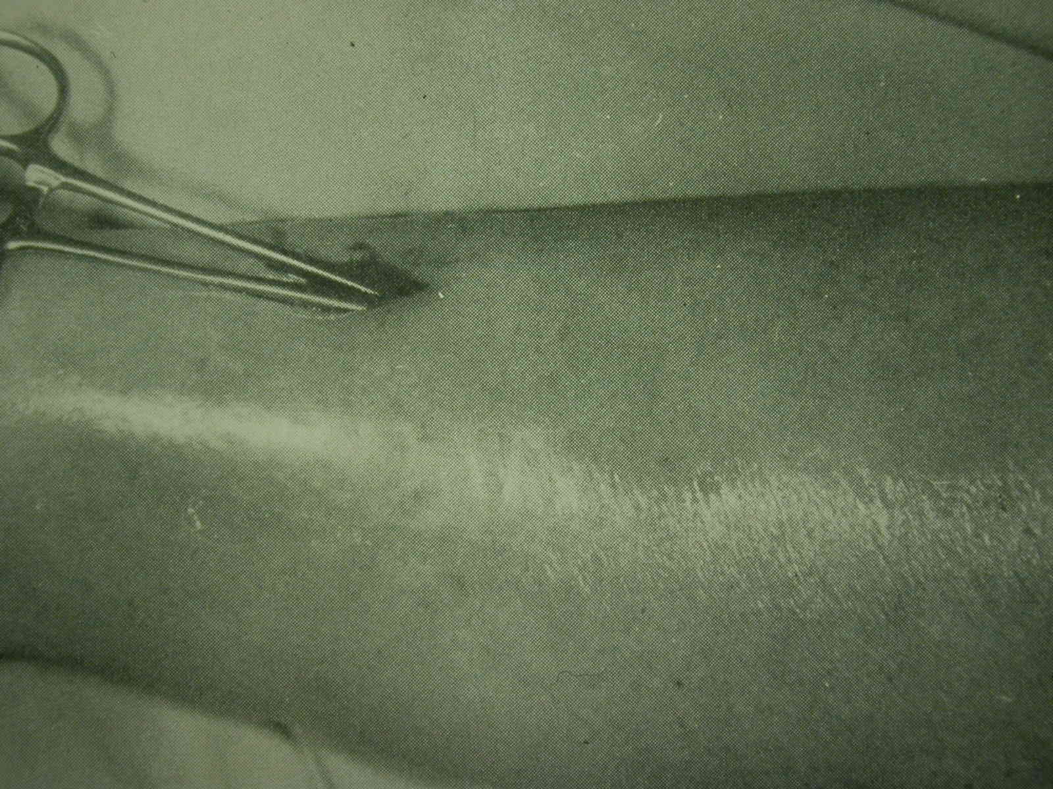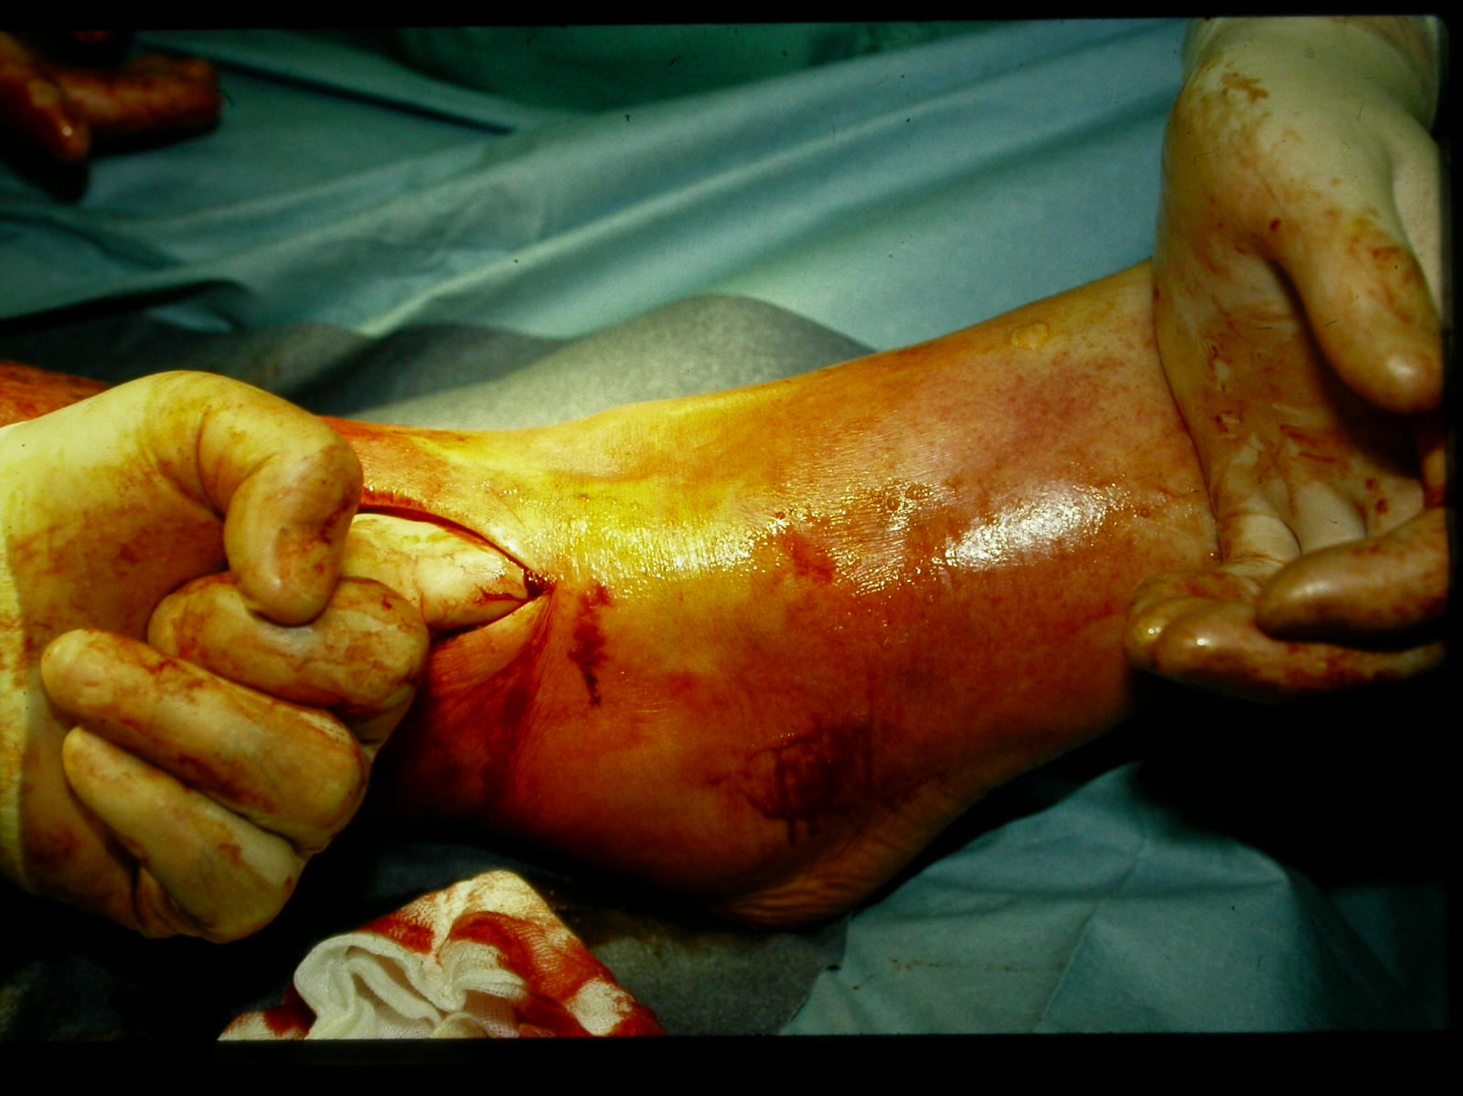
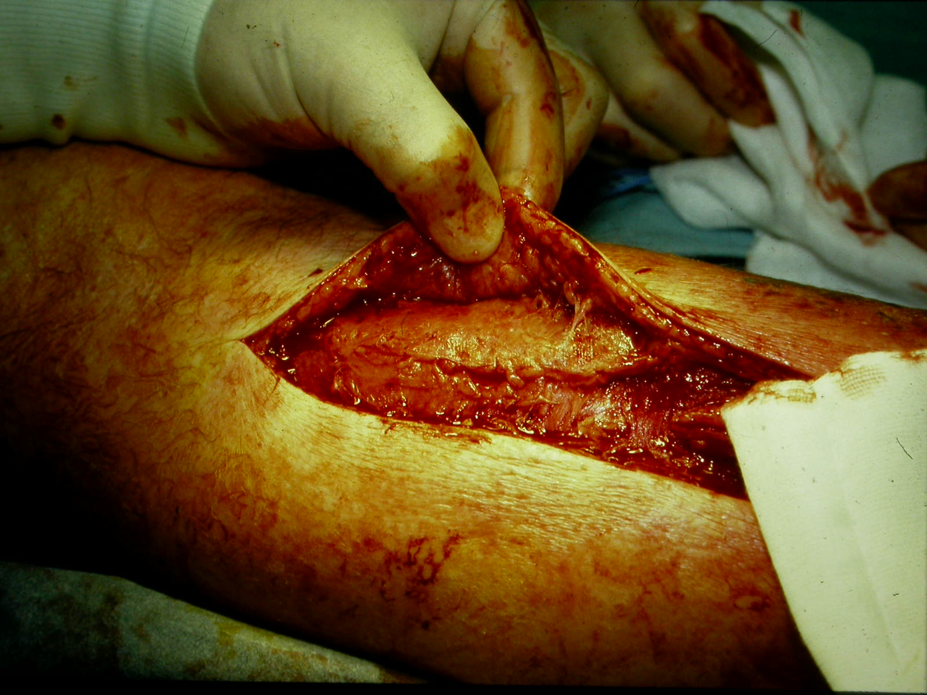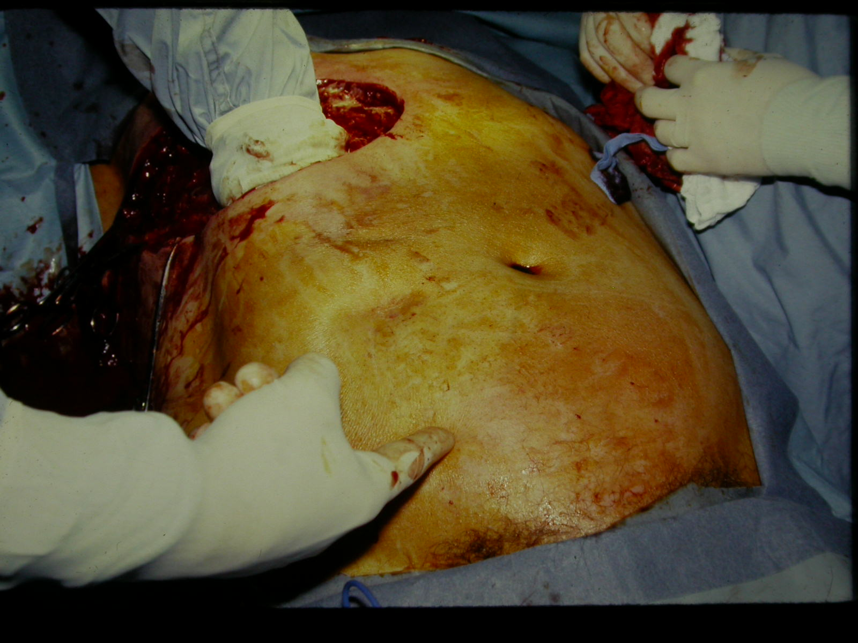

Micro dx: gm stain and culture infected tissue; it may influence antibiotic rx and epidemiology, especially if unimicrobial. Aspiration of injected saline has ~20% yield.

Treatment of SSTI
Treat simple cellulitis with antibiotics (clox or pen + clox or cefazolin usually appropriate) and close observation (NEJM 2004;350:904. If not improving in 24 hr add Gm neg and anaerobe coverage, consider Type 2 infection.

Treatment of type 2 infections is similar regardless of microbial etiology or tissue level: aggressive debridement and excision. May need amputation. Resusc with O₂ and fluids. Usually can spare testicles in perineal SSTI (“Fournier’s gangrene”) because of independent blood supply, unless internal spermatic artery thrombosed.

Unless unimicrobial infection confirmed (eg strep or clostrid), target Gm pos cocci, Gm neg rods and anerobes eg pen, quin + clinda or metro OR imipenem/meropenem/ertapenem. No good antibiotic trial.

Hyperbaric O₂ recommended for clostridial myonecrosis, limited to centres (eg TGH) where available - clinical efficacy unproven, but strong theoretical and anecdotal support. DON’T DELAY OPERATION FOR HYPERBARIC O₂. Hyperbaric O₂ may help resid infection if excision not practical eg head + neck or pt refuses amput

Three clinical syndromes deserve mention:
CLOSTRIDIAL MYONECROSIS = “ GAS GANGRENE”
Microbiology: C. perfringens, other clostridia
At Risk : 1) trauma 2) abdominal surgery 3) spontaneous – diabetes, vascular
insufficiency, perirectal abscess: esp if ↓ blood supply

Pathogenesis: Bact toxins and hemolysins → shock, ARF assoc with muscle necrosis

Clinical: Severe pain, crepitus usually, sepsis; vascular collapse

- NECROTIZING FASCIITIS AND NECROTIZING CELLULITIS
Microbiology: Single organism (less common): strep, clostridia, gm negs, others. Usually polymicrobial coliforms + gm neg anaerobes ie GI flora

At risk: Diabetes, obesity, unresolved contiguous infection

Clinical: Most common type 2 infection. Skin discolouration, blistering. “Dishwater pus”

- “MELENEY’S GANGRENE,” “PROGRESSIVE SYNERGISTIC GANGRENE.” Very uncommon, except for textbooks and exams
Microbiology: microaerophilic nonhemolytic strep + S. aureus

Clinical: Tender circumferential cellulitis. Black centre, then purple, then red on outside. Burrowing tracts. Treatment: antibiotics +/- wide excision

TOXIC SHOCK SYNDROME (TSS)

Micro/clinical: Toxin-mediated shock and MODS assoc with S. aureus or S. pyogenes infections. Origin vagina (S. aureus, tampons), surgical wound (especially S. aureus), SSTI (especially S. pyogenes) or obscure. Mortality ~15%.
Rx: hi dose clox or pen plus clinda (↓ toxin production). Add IVIG, especially for Strep; IVIG neutralizes superantigen and has trend to ↓ mortality CID 2003;37:333 – d/c’d mid-trial, placebo group ↑M, used now in Toronto, controversial

For invasive S. pyogenes infections (ie nec fasciitis + TSS) routine screening/proph of household contacts not indicated, but consider for hi risk (chickenpox, HIV, diab, cancer, hrt dis, IV drugs, steroids: CID 2002;35:950). MSH has expertise and database.

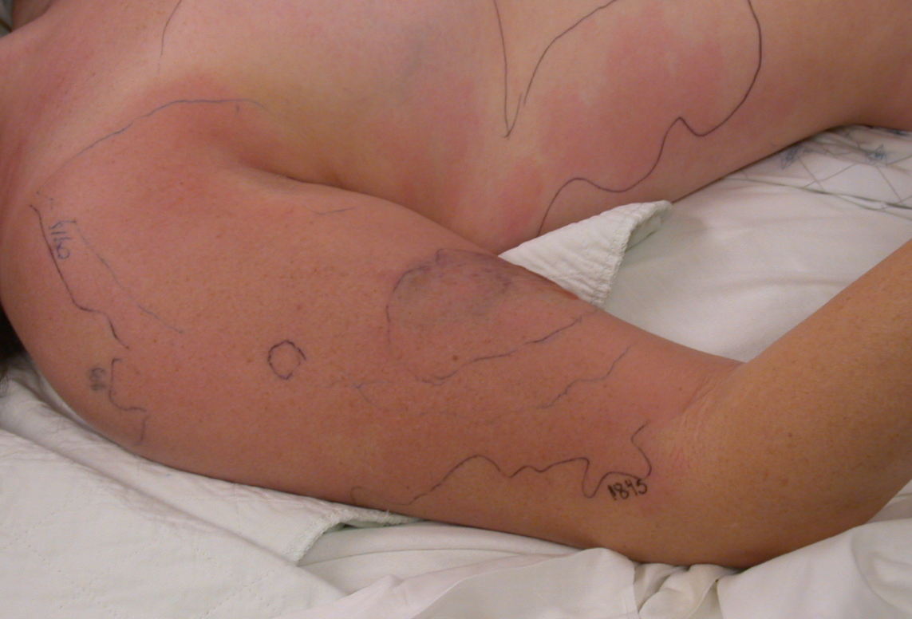

TETANUS

Micro/at risk: Clostridium tetani. Trauma, severe contamination especially fecal, dead tissue or decreased blood supply (it’s an anaerobe), heroin addiction, bites, neonatal oomphalitis LACK OF PREVIOUS IMMUNIZATION! Full immunization prevents the development of tetanus.

Pathogenesis: C. tetani spores become vegetative where local anoxia
→ tetanospasmin (a neurotoxin) which travels in blood and/or along axons. The toxin inhibits inhibitory neurotransmitters leading to spasm, irritability. Incubation takes a few days to 3 wks, depends on the proximity of the site to CNS
Clinical forms
Local: Mild, but may become generalized
- Cephalic: Rare, head injury a cause, involves VII n, may become generalized
- Generalized – 80% of cases. Local tingling at first, then muscle rigidity, ↑ T 2-4ºC, seizures,autonomic: ↑ HR, ↑ ↓ BP, arrhythmia;

Prevention is crucial (Bull Amer Coll Surg 81:42, 1996); elderly less likely immune:
Clean, minor wounds under 6 hr:
Immunization HX  “uncertain” to 2  three or more | Toxoid  yes  no  (unless > 10 yr since last dose) | TIG  no  no

All other wounds (i.e. tetanus-prone), including burns, frostbite:
Immunization HX  “uncertain” to 2  three or more | Toxoid  yes  no  (unless > 5 yr sincce last dose | TIG  yes  no

Scheme above modified slightly from CDC and ACS, for ease of recall. Most ERs have latest CDC recommendations. Confirm immunization history from records.

Post-exposure prophylaxis
Passive – 500 units human immune globulin (TIG)
Active immunization – give toxoid at a site remote from TIG
Penicillin – only in very dirty wounds
DEBRIDEMENT! (give antitoxin first if indicated, debridement may liberate toxin
N.B. Natural disease does NOT confer immunity; these patients require immunization

Treatment of Established Tetanus: ICU, early airway; quiet room, diazepam, barbiturates, curare; β blockade for ↑ HR; phentolamine, guanethidine for ↑ BP; TIG, immunization, penicillin or metronidazole
Prognosis: 18% mortality, increases with age

ANTIBIOTIC PROPHYLAXIS FOR BITES
In addition to information on this table, debride and prevent tetanus and rabies as above and below: ie “Amox/clav, rabies, tetanus”

Animal | Bugs | Drugs | Comments
Bat, raccoon, skunk  Cat  Dog  Human  Rat | unknown  Pasteurella multocida and S. aureus  Same as cat plus some anerobes  Streps, staphs, anerobes, Eikenella  Spirillum and strep | amox/clav  amox/clav  amox/clav  amox/clav  amox/clav | rabies!  80% become infected; switch to pen if P. multocida cultured; clox and cephalexin do not cover P. multo  Only 5% become infected, so antibiotics controversial  Tooth puncture on fist = bite  don’t worry about rabies

RABIES
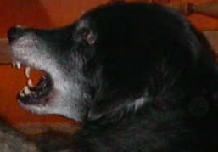

1. Infection fatal; only survivors received prophylaxis before symptoms.
2. 11th most common infection killer in the world (but only ~3 cases/yr in USA).
3. Only 22 deaths in Canada since 1925 but infected animals probably increasing.
4. Most deaths now 2° to bat exposure without bite (CID 35:738,2002, CMAJ 167:781,2002, NEJM 351:2626, 2004)

PREVENTION (NEJM 351:2626, 2004)
(Wound care important too):

Animal  Wild  skunk  bat  fox  coyote  raccoon  Domestic  dog/cat  dog/cat  dog/cat  dog/cat  Other  rodents  rabbit | Status of Animal  regard as rabid  healthy  escaped (unknown)  rabies confirmed  rabies suspected | Rx  HRIG + vaccine  (D/C if brain neg)  (HRIG = human rabies immune globulin)  none (treat if signs of rabies during observation of animal)  HRIG + vaccine  HRIG + vaccine  HRIG + vaccine (D/C if brain neg for virus)  None
Incubation period usually 20-90 days, shorter for bite on head, ranges 4 days to years.

NOTE: give prophylaxis for mere presence of bat in room of person sleeping unattended or incapacitated (eg drunk), test rather than release bat if exposure cannot be ruled out; squirrels, chipmunks, rabbits: 0.1% are infected; have never been implicated in human rabies in U.S.; treat only if unusually aggressive. Domestic dog or cat, unprovoked – hold for 10 days to observe

Vaccine: in deltoid; don’t use same syringe as for HRIG. HRIG: ½ in wound area, ½ in ant thigh. WASH WOUND THOROUGHLY WITH VIRUCIDE IF POSS (EG POVIDONE-IODINE). HRIG + vaccine always effective, generally well tolerated.

Give pre-exposure proph in those at risk (eg vets). Post-exposure prophylaxis is urgent – make decision ASAP – delay probably affects outcome.

Treatment: 1st reported survival with multimodality rx without immune prophylaxis (NEJM 352:2508, 2005). Before, all fatal exc 5 survivors who got proph before symptoms

SOME POINTS ABOUT ABSCESSES

S. aureus causes abscesses everywhere. Antibiotics DO penetrate abscesses in most cases, but may be inactivated. Treat most abscesses with drainage and antibiotics.
Some exceptions:
brain abscess
lung abscess
Antibiotics alone often enough
amebic abscess
multiple small liver abscesses
tubo–ovarian abscess

ACTINOMYCOSIS

Microbiology Actinomyces is a gram positive branching anaerobic rod. A. israelii is most common (there are others), and is not an opportunistic organism nor is it a fungus. Colonization of humans is natural reservoir but it does not transfer person to person.

Pathology Enters thru break in GI mucosa 2° to disease/trauma. Sinus tracts and fistulae typical. Sulfur granules, mineralized masses of bacteria up to 2mm in diameter, sometimes visible to the naked eye, also found in Nocardia and other infections. The inflammatory reaction is characterized by granulomas with neutrophil infiltrate. Any path report with unexpected “granuloma” – think TB, actino, foreign material, Crohns.

Clinical: Four types, usually present chronically:

- Cervicofacial (almost half of cases), 2 types: a) painless, indolent b) painful, spreading, invasive
- Thoracic – 2° to dental disease plus aspiration. Lung disease may be diffuse, with small cavities. Pleura and heart may be involved.
- Abdominal – suspect diagnosis with any unexpected fistula formation or persistence; can occur 2° to any gut operation/condition esp ileocecal, anorectal, adnexal.
4) CNS – abscess anywhere in CNS 2° to hematog spread; brain 75%.

Treatment High dose, long-term pen or amp/amox (10-20 million u pen G or 3 g amp IV daily for 4-6 wks, followed by po pen or amox for 6-12 mo for severe or well established cases). Operate where appropriate to drain abscess or resect grossly infected tissue.

TUBERCULOSIS

Mycobacterium tuberculosis, spread by aerosols, causes almost all cases. After inhalation the organisms spread, then become dormant but remain viable. They are reactivated when systemic host defenses (esp cell-mediated immunity) dysfunction (e.g. advanced age, malnutrition, AIDS, lymphoma). A positive skin test indicates previous exposure. The diagnosis requires demonstration of acid-fast bacilli, confirmed by positive TB culture (some Mycobacteria are not TB). TB can cause multisystem disease: pleuropulmonary, meningitis, pericarditis, renal, osteomyelitis, lymph nodes and peritonitis. Consider TB in cases of chronic or subacute undiagnosed syndromes in patients at risk because of altered immunity. Rx: combo antibiotics, resistance problem.

OVERWHELMING POST – SPLENECTOMY INFECTION (OPSI)

Microbiology Frequently lethal infection mainly in kids. Uncommon, < 2% of kids post-splenectomy; also functional asplenia eg sickle disease. S. pneumoniae most common pathogen, + other encapsulated bacteria (meningococci, H. influenzae). Nausea, vomiting, confusion progress rapidly to death within hours despite hi dose pen. Source usually obscure. Blood cultures are positive, bacteria often seen on blood smear.

Prophylaxis: Prophylaxis includes spleen preservation esp in kids. Give pneumococcal, meningococcal and “H flu” vaccines (per CPS) before elective or after emergency splenectomy though do not cover all bacterial strains. Repeat pneumococcal vaccine q 6 yrs. Vaccines have few side effects. Kids should get pen daily for 3 yrs following splenectomy. Asplenic patients should carry amox or amox/clav always, take if fever.

Treatment Ceftriaxone or cefotaxime IV. If gram stain and cultures reveal S. pneumoniae, switch to pen.

